1. Even despite the fact that in video you will see main concepts related to specific topic, I encourage all students to read books. Why? Our brain works the way it cannot consume 100% of information. And even in case you will review the video lessons multiple times, your brain will skip some details unintentionally. To ensure you absorb as much information as you can, I recommend you to read the same topic in different books. In this document I will tell you where you can download these books.   
     
   Here recommended literature for this course:
   1. Java: The Complete Reference - Herbert Schildt
   2. Thinking in Java - Bruce Eckel
   3. Core Java Volume I - Fundamentals - Cay S. Horstmann

These are the best books which helped to grow up for a few generations of Java developers.  
 I would recommend during your learning read the same topic in different books. That will guarantee that you understand a specific topic, because you will learn it from different points of view.

During the course in the homework you will find reference to one of the books. For example: “Read chapter #N, about primitive types in ‘Java: The Complete Reference’ ”. In this case, feel free to find the same topic in other books in Table of Contents and read it.   
  
Reading books is an ***optional task*** in most cases, because I described the main things in the video lesson, but I encourage you to read them.

1. Read ‘The History and Evolution of Java’ chapter from *Java: The Complete Reference - Herbert Schildt*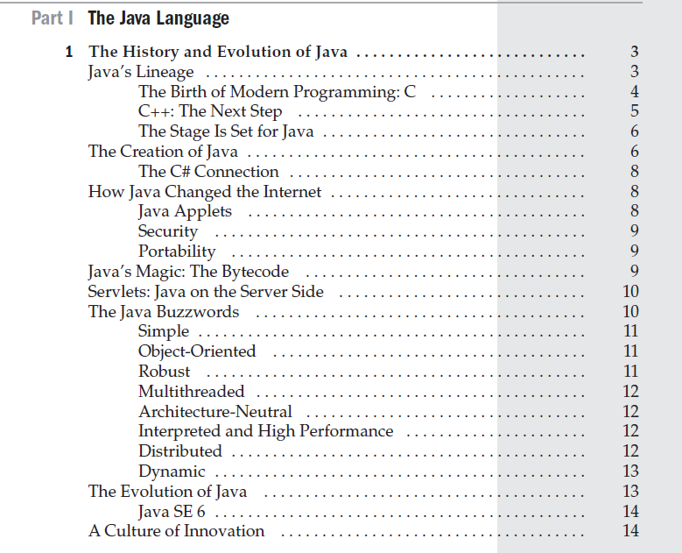
2. ***During the course do not forget to do the next thing for effective learning:*** each time you would see lines of code in the book - rewrite them into your IDE workspace. This simple exercise will help you to understand a lot of things deeper. And you will start raising questions in case something still unclear for you.

## **WHERE TO FIND BOOKS:**

1. First of all, you can find these books by making a google search query to find the .pdf version of the book. For example, you can query like this:  
     
   ***Java: The Complete Reference - Herbert Schildt pdf download***You can easily find books on the Internet like this.   
   In case you don’t want to search in google - I have another option for you.
2. There are a lot of interesting and useful books in the Telegram messenger app. Now I will tell you how to download books from telegram.   
   1. First of all, download desktop version of telegram messenger here - <https://desktop.telegram.org/>
   2. The next thing to do is to join this channel <https://t.me/learnit_itbulls> - in this channel you will find a lot of books
   3. When you joined the channel - click on the channel header like on the screenshot below  
        
      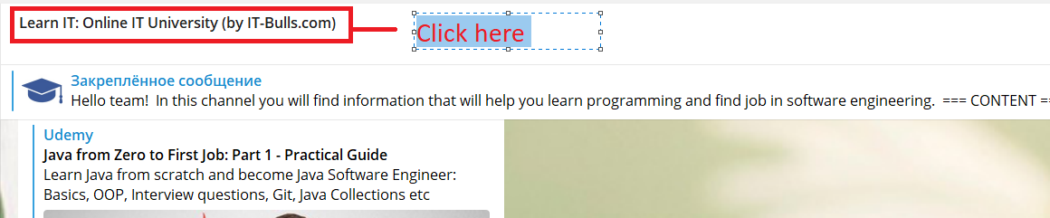
   4. Select ‘files’ like shown on the screenshot  
        
      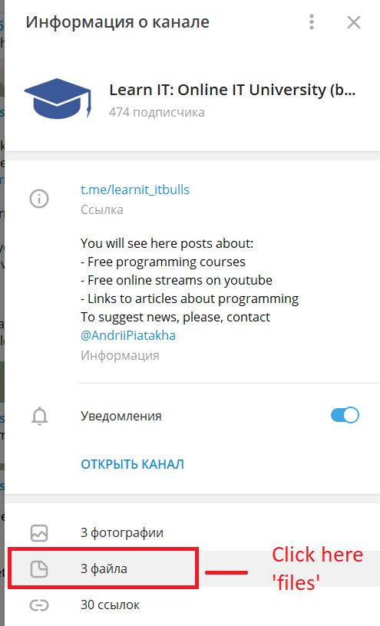
   5. And here you can find books that you was looking for (like on the screenshot below)   
        
        
        
      